Experiment:30 Date:18/08/2027

FORWARD CHAINING

Aim
To write a Prolog program to implement forward chaining.

Algorithm
- Start with a set of known facts.
- Define rules using the available facts.
- Check the conditions of each rule.
- Derive new facts when the rule conditions are satisfied.
- Continue until the required conclusion is obtained.

Program
fact(rain).
fact(cloudy).

rule(wet_ground) :-
fact(rain).

rule(carry_umbrella) :-
fact(rain).

rule(stay_inside) :-
fact(rain),
fact(cloudy).

infer(X) :-
fact(X).

infer(X) :
rule(X).

OUTPUTS:

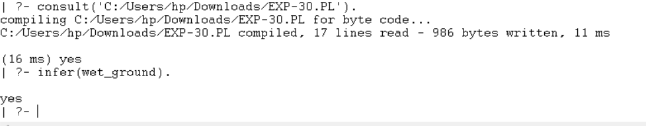

RESULTS:
Thus, forward chaining was successfully implemented using facts and rules in Prolog.

